- Please hide ongoing support and event specific options under services - Done
- Remove the option for scheduling a meeting at the start. It will create confusion. - Done
- Under agenda tab, please add different options like 10 mins, 20 mins, 30 mins and so on. Doing it manually is inconvenient for the user. - Done
- Please add an option to add participants directly from advisory board platform - Done
- I could not add documents kindly check below screenshot. It is showing some error. - Done
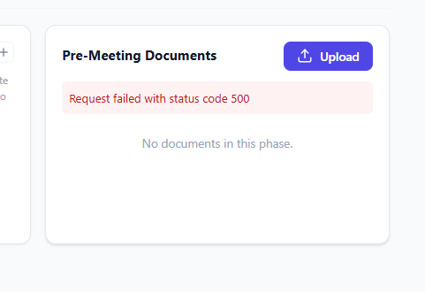
- There is no option to send documents/agenda/survey link to the participants. There should be an option to send all of these or share a link with them so that they can prepare before the meeting. If we will share the link, we can audit them also. - Done
- No one was able to join the meeting. Check below screenshot. - Done
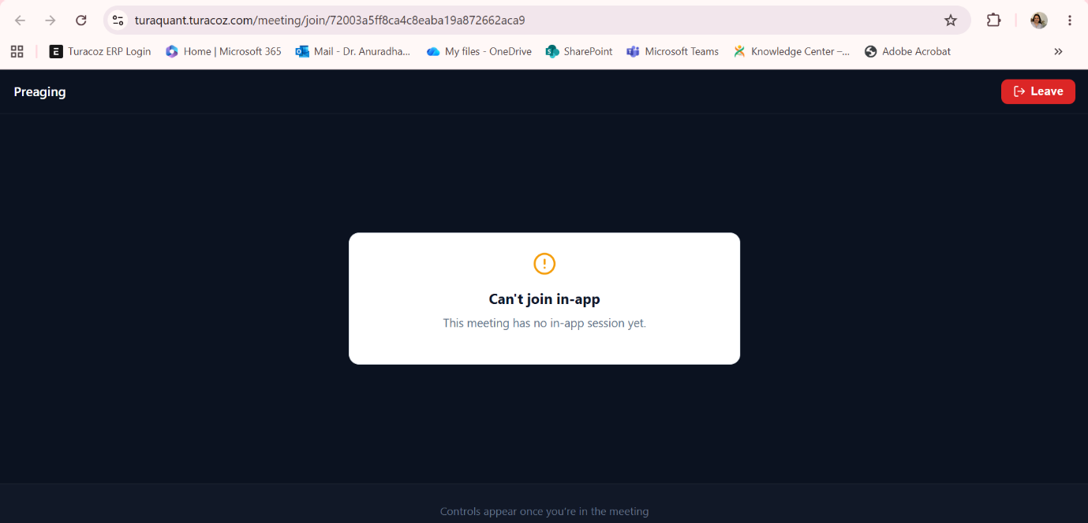
- The mails I have sent to the participants have come from TuraDome name. Kindly correct. Check screenshot below. - Done
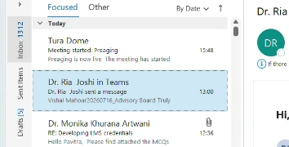
- There is no option for me to join the meeting. I am able to start the meeting, but I am not able to join from the platform. - Done

